Collections class
- Java collection class is used exclusively with static methods
- Ms ➔ this class has the static method for synchronizing set, map, list and also it has the method for sorting, searching
- Ms ➔ Collection is from Util Package
- Needed to collect more information on Collections class

Sorting in Collection
- Collections class provides methods for sorting the elements of List type elements➔ public void sort(List list)
- We can sort the elements of the following classes
- String
- Wrapper classes
- User defined class
- String class and Wrapper classes implements the Comparable interface.So if you store the objects of string or wrapper classes, it will be Comparable
Comparable interface
- Java Comparable interface is used to order[ms sort] the objects of user-defined class.
- public int compareTo(Object obj): ➔is used to compare the current object with the specified object.
- Syntax for Comparing user defined object 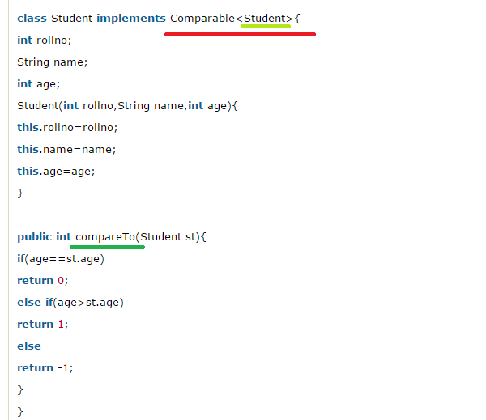
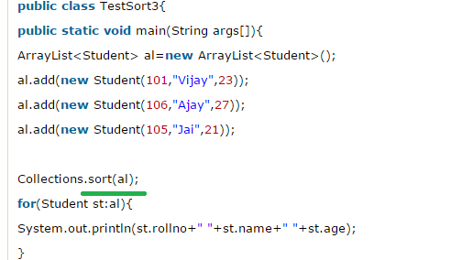
- Look at here for comparing an list object we are using the Sort() method of the Collection class
- Suppose if the List object is String or Wrapper we don’t need to use Compare Method as this class already Overrides the compareTo method of the Comparator interface
- But in our case we are Sorting the Userdefined object hence the Userdefined Object which needs sorting have to be Implementing the Comparable method compareto()
- That’s why Our user defined class Student implements compareTo() method
- Note Our user object Student have following member valriables ➔name, age and Id , among this all three we can do sorting/comparing on any one variable only
- Now lets see the relation shop between sort() and compareTo() methods

How does the sort() method of the Collection class call the Comparable's compareTo()?
sort() method Sorts the specified list into ascending order, according to the natural ordering of its elements. All elements in the list must implement the Comparable interface."
The Comparable interface specifies the compareTo method which provides the "natural ordering" that the javadoc refers to.
Note ➔sort() calls the compareTo method when it needs to compare a pair of Object/Element

Java Comparator interface
- Java Comparator interface is used to order the objects of user-defined class
- This interface is found in java.util package and contains 2 methods compare(Object obj1,Object obj2) and equals(Object element)
- Compare(obj1, obj2)➔ is a static method
- Syntax:
- Note if you look At the syntax of the Comparator class then it will be coear for you ➔ Ms Comparable helps to do compare just only one member variable butby using Comparator I can compare any number of memberVariables lets see it
- Step1:
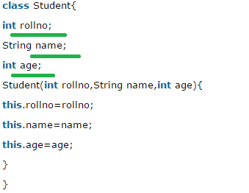
Step 2: here If age of first object is greater than the second, we are returning positive value, it can be any one such as 1, 2 , 10 etc.
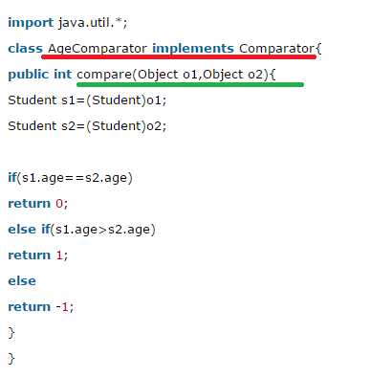
Step 3:
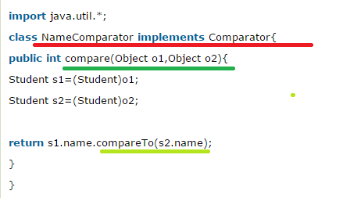
Step 4: Now lets see the test class syntax, here we are going to do sorting based on age and then display its result and then we are going to do Sorting based on name and then display its result ➔ ms screet shot I had taken 2 for one single class to simplify
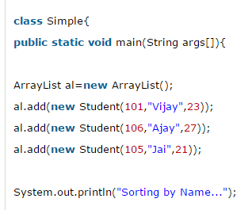
Now lets see the code for Sorting by name java code
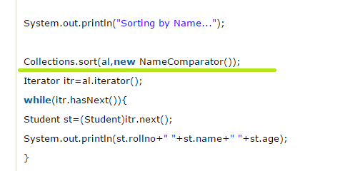
Now lets see the code for Sorting by age java code
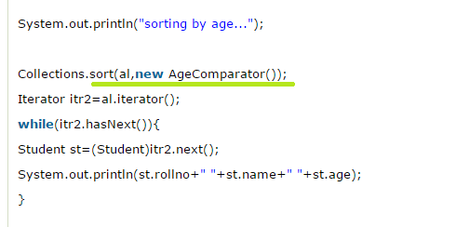
Output :
